A Major Project Synopsis on

**AR Based Navigation System**

Submitted to Manipal University, Jaipur

Towards the partial fulfillment for the Award of the Degree of

**MASTER OF COMPUTER APPLICATIONS**

2023-2025

by

Shubham Pant

23FS20MCA00019



Under the guidance of

Dr. Timothy Malche

**Department of Computer Applications**

**School of AIML, IoT&IS, CCE, DS and Computer Applications**

**Faculty of Science, Technology and Architecture**

**Manipal University Jaipur**

**Jaipur, Rajasthan**

**2025**

1. **Introduction**

An AR (Augmented Reality) based navigation system is a technology that uses augmented reality to provide users with directions and guidance in real-time. It overlays digital information and graphics onto the physical world, creating a virtual layer that users can interact with.

The system works by using sensors such as GPS, accelerometers, and gyroscopes to track the user's location and orientation in real-time. The AR technology then uses this data to create a virtual map of the surrounding area and provide visual cues to guide the user.

AR-based navigation systems are designed to enhance the user's experience by prov -iding a more immersive and engaging way to navigate their surroundings. They can be used in a variety of applications, including outdoor navigation, indoor navigation, and even in automotive navigation systems.

One of the key advantages of AR-based navigation systems is their ability to provide users with context-specific information. For example, they can display information about nearby landmarks, historical sites, or points of interest, making navigation more informative and engaging.

Overall, AR-based navigation systems are an exciting development in the field of navigation technology, and they have the potential to revolutionize the way we navigate our world.

**Why should you use Ar based navigation System?**

1 The primary goals of an AR-based navigation system are to provide users with accurate and efficient guidance, as well as an engaging and immersive experience. Here are some specific goals of an AR-based navigation system:

* + Provide real-time guidance: The system should be able to

provide users with accurate and real-time guidance, taking into

account their current location, orientation, and destination.

* + Enhance situational awareness: AR-based navigation

systems should help users better understand their surroundings by providing relevant information about landmarks, buildings, and other points of interest.

* + Create an immersive experience: The system should use

AR technology to create an immersive and engaging experience that is both informative and enjoyable.

* + Increase safety: Navigation systems should prioritize

safety by providing clear and concise directions, warningusers of potential hazards, and guiding them away from dangerous areas.

* + Enable easy customization: The system should allow users

to customize the display of information, such as adjusting the size and placement of AR markers.

* + Support multi-modal navigation: The system should

support different modes of navigation, such as walking, biking, or driving, and provide appropriate guidance for each mode.

Overall, the goal of an AR-based navigation system is to make navigation more intuitive, informative, and enjoyable, while also ensuring the safety of users.

1. **Motivation**
   1. AR-based navigation systems offer several advantages over traditional navigation systems, which are primarily based on maps and text-based directions. Some of the key benefits of AR-based navigation systems include:
   2. Enhanced situational awareness: AR-based navigation systems provide users with a more comprehensive understanding of their surroundings, including points of interest, landmarks, and other important information. Thiscan help users better orient themselves and navigate more effectively.
   3. More intuitive navigation: AR-based navigation systems provide users with visual cues and directions that are more intuitive than traditional map-based directions. This can be especially helpful for people who struggle to read maps or have difficulty following text-based directions.
   4. Improved safety: AR-based navigation systems can helpimprove safety by providing users with real-time information about potential hazards and obstacles in their path. For example, an AR-based navigation system could highlight the location of a pedestrian crossing or provide a warning about road closures ahead.
   5. Increased efficiency: AR-based navigation systems can help users save time and reduce frustration by providing them with more efficient routes and real-time traffic updates.
   6. Overall, AR-based navigation systems have the potentialto make navigation more intuitive, efficient, and safe, and may become increasingly important as more people rely on digital navigation systems to navigate their surroundings.
2. **Problem Statement**

Without AR-based navigation systems, users may face several challenges when navigating their surroundings, particularly in unfamiliar or complex environments. Some of these challenges include:

* Difficulty orienting oneself: Traditional map-basednavigation systems can be difficult to use for people who struggle to read maps or have difficulty interpreting text-based directions. This can make it difficult for users to get their bearings and navigate effectively.
* Limited situational awareness: Traditional navigation systems may provide users with limited information about their surroundings, such as nearby landmarks or points of interest. This can make it difficult for users to get a comprehensive understanding of their surroundings and make informed navigation decisions.
* Safety concerns: Traditional navigation systems may not provide users with real-time information about potential hazards or obstacles in their path, such as road closures or pedestrian crossings. This can increase the risk of accidents or other safety issues.
* Inefficient routes: Traditional navigation systems may not always provide users with the most efficient routes, particularly in areas with heavy traffic or complex road systems. This can lead to increased travel times and frustration for users.

1. **Solution:**

AR-based navigation systems can improve navigation in several ways. Here are some examples:

* + More accurate and precise directions: AR-based navigation systems can use a combination of GPS, sensors, and mapping technologies to provide more accurate and precise directions. This can help users navigate more efficiently and avoid getting lost.
  + More intuitive guidance: AR-based navigation systems can use

visual cues such as AR markers or 3D objects to guide users, making navigation more intuitive and easy to understand. For example, an AR-based system could display arrows or other

graphics to show users which way to turn at a street corner.

* + Increased situational awareness: AR-based navigation systems can

provide users with relevant information about their surroundings, such as the names of nearby streets, buildings, or points of interest. This can help users better understand their surroundings and

navigate more confidently.

* + Enhanced safety: AR-based navigation systems can provide users

with warnings or alerts about potential hazards, such as

construction zones or traffic congestion. This can help users avoid dangerous situations and stay safe while navigating.

* + Customization: AR-based navigation systems can allow users to

customize their display settings to suit their individual preferences. For example, users could adjust the size or placementof AR markers or choose which types of information they want to display

1. **Minimum Requirements for proposed work:**

To deploy the application, the minimum technical aspects needed are mentioned below:

* + Operating Environment Win 2000/XP or higher

OR

* + MacOS Sequoria 15.3.2 or higher
  + Android Studio(version 2024.3.2 Canary 8)

**For Users:**

* Camera
* Support AR Application
* Internet Connection

1. Minimum Hardware Requirement For Development:
   1. Processor: Minimum Intel i3 or higher
   2. RAM: 4GB or higher
   3. Storage: 10GB free space for development
2. **Design Flow / Process:**

## **Analysis of Features and finalization subject to constraints**

* 1. **Identify Constraints:**
* List and evaluate any restrictions that might affect how the AR-based navigation system is implemented. Technical limits, financial restrictions, time restraints, resource availability, and legal requirements are only a few examples of these limitations.
  1. **Review Existing Features:**
* Review the list of previously named features for the navigation system based on augmented reality.
* Each feature should be evaluated in the context of the defined restrictions, and its viability within those constraints should be determined.
  1. **Remove Features:**
* Identify things that would be difficult or impractical to implement within the aforementioned restrictions.
* Eliminate elements that might drastically raise development costs, demand a lot of resources, or contravene legal restrictions.
  1. **Modify Features:**
* Assess features that require modifications to fit within the identified constraints.
* Consider methods to improve features by making them easier to develop, using less resources, or using other strategies.
  1. **Add Features:**
* Identify any new features that might improve the AR-based navigation system's usefulness or solve certain limitations.
* Take into account elements that can enhance user experience, boost system effectiveness, or adhere to certain regulatory standards.
  1. **Prioritize Features:**
* Sort the remaining features according to significance, viability, and fit with the project's objectives.
* Think about how each addition will affect system speed, user experience, and overall functioning.
  1. **Finalize Feature Selection:**
* Finalize the selection of features based on the prioritization and assessment within the identified constraints.
* Record the features that were chosen, any changes or additions, and the reasons why they were chosen.

## **Design Flow**

Two different design flows or procedures for developing a solution for the AR-based navigation system will be given in this section. These design flows show many methods for finishing the system and reaching the project's goals.

**A Different Design Flow 1:**

1. **Requirements Gathering**

* Conduct extensive research and gather user requirements to understand their needs and expectations from the AR-based navigation system.
* Based on user input, industry standards, and technology capabilities, identify the important features and functionalities.

1. **System Architecture Design:**

* Create the overall system architecture, taking into account the necessary hardware and software for the AR-based navigation system.
* Define the interfaces, communication protocols, and data flow between the various modules.

1. **AR Technology Selection:**

* Evaluate different AR technologies available, such as marker-based AR, markerless AR, or SLAM (Simultaneous Localization and Mapping) techniques.
* Considering aspects like accuracy, performance, device compatibility, and user experience can help you choose the best AR technology.

1. **Development:**

* Use the appropriate programming languages and development frameworks to implement the chosen design.
* Create modules for essential features including route planning, mapping, augmented reality visualisation, and user interface.

1. **Integration and Testing:**

* Create a system that combines the created parts.
* Conduct thorough testing to validate the AR-based navigation system's performance, accuracy, and usefulness.
* To obtain input and make the required adjustments, do user testing.

1. **Iterative Refinement:**

* Examine the user testing input and adapt the system as necessary.
* Fix issues, incorporate user feedback, and boost speed to improve the user experience as a whole.

1. **Deployment and Maintenance:**

* Prepare the AR-based navigation system for deployment, considering factors like installation, device compatibility, and user support.
* Create a maintenance schedule to handle any upcoming upgrades, bug patches, or system improvements.

**Alternative Design Flow 2:**

1. **Rapid prototyping:**

* Utilising commercially accessible components and existing AR development tools, quickly create a prototype of the AR-based navigation system with the most fundamental features.
* Obtain user input early on in the process to comprehend their preferences and improve the system specifications.

1. **Agile Development:**

* Use iterative sprints and an agile development methodology to continually create and improve the AR-based navigation system.
* Prioritise and gradually roll out features in accordance with user feedback and project objectives.

1. **Collaborative Design:**

* Involve users and stakeholders in the design process through workshops, feedback sessions, and usability testing.
* Obtain feedback from many viewpoints to make sure the system satisfies the range of user demands.

1. **Parallel Development:**

* Assign separate teams or developers to work on different modules simultaneously, such as positioning, mapping, AR visualization, and user interface.
* Encourage efficient teamwork and communication to guarantee the modules' flawless integration.

1. **Continuous Testing and Feedback:**

* Conduct frequent testing throughout the development process to identify and address any issues or bugs.
* To verify the system's performance, usability, and usefulness, routinely collect user input.

1. **Integration and System Refinement:**

* Refine the system based on user feedback and testing results after integrating the developed modules into a comprehensive one.
* Enhance user experience, boost performance, and fix any flaws you find.

1. **Deployment and Continuous Improvement:**

* Provide users with access to the AR-based navigation system while keeping an eye on its effectiveness and soliciting continuing input.
* Keep the system up to date and improved depending on user requirements, technology developments, and new trends.

## **Implementation plan/methodology**

* + - 1. **Requirements Analysis:**
* Conduct a thorough analysis of user requirements, technical constraints, and system objectives.
* Describe the functional and non-functional requirements for the navigation system based on augmented reality.
  + - 1. **System Design:**
* Create a thorough system design that outlines the overall architecture, the components, and how they work together.
* Make an algorithm or flowchart to show the logical progression of the system's functionality.
  + - 1. **Data Acquisition and Preprocessing:**
* Identify the data sources, including GPS, maps, and sensor data, that the navigation system needs.
* Implement methods for gathering and preprocessing data in preparation for future processing.
  + - 1. **Positioning and localization:**
* Create methods or algorithms that precisely pinpoint the user's location in a real-world setting.
* Incorporate positioning technologies like GPS, indoor localization, or computer vision-based methods.
  + - 1. **Mapping and Augmented Reality Visualization:**
* Implement mapping algorithms to create and update a digital representation of the environment.
* Create augmented reality visualisation techniques to add pertinent information to the user's perspective.
  + - 1. **Route Planning and Navigation:**
* Design algorithms to calculate optimal routes based on user preferences, traffic conditions, and other relevant factors.
* Implement navigational features that offer real-time guiding and turn-by-turn directions.
  + - 1. **User Interface and Interaction:**
* Design an intuitive and user-friendly interface for interacting with the AR-based navigation system.
* To improve user experience, incorporate functions like voice commands, gestures, or touch interfaces.
  + - 1. **System Integration and Testing:**
* Integrate and test the developed modules and system components to create a functioning whole.
* Test the AR-based navigation system thoroughly to ensure its performance, accuracy, and functionality.
  + - 1. **User Feedback and Iterative Refinement:**
* Utilise user surveys and usability testing to gather user input.
* Analyse the comments and make the required adjustments to enhance the system's performance and usefulness.
  + - 1. **Deployment and Maintenance:**
* Prepare the AR-based navigation system for deployment on the intended platforms, such as smartphones or AR glasses.
* Create a maintenance schedule to handle any upcoming upgrades, bug patches, or system improvements.

**Flowchart for AR-based Navigation System**

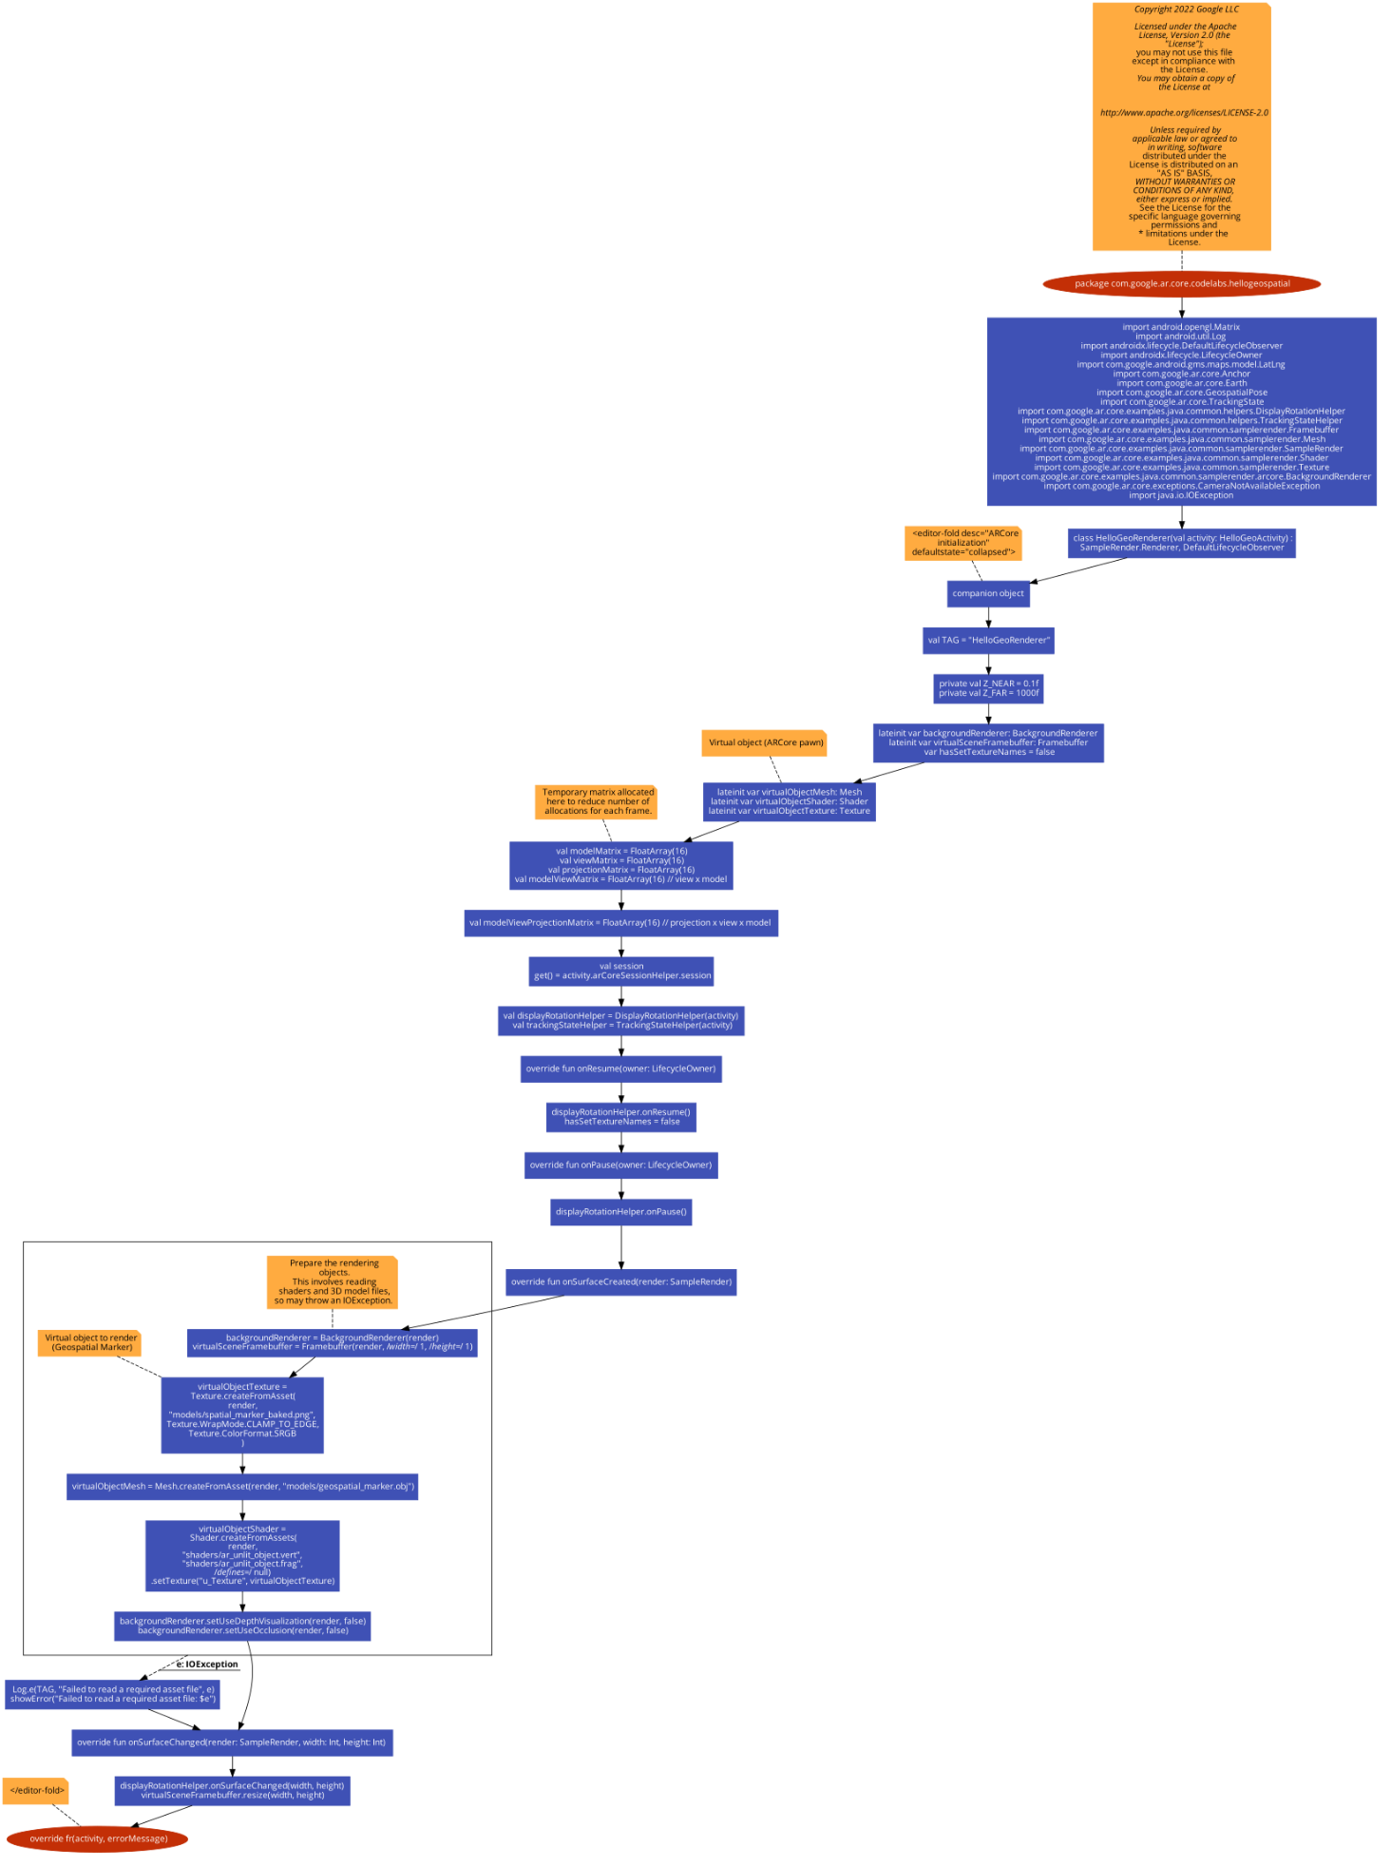

Fig 3.1 Flowchart

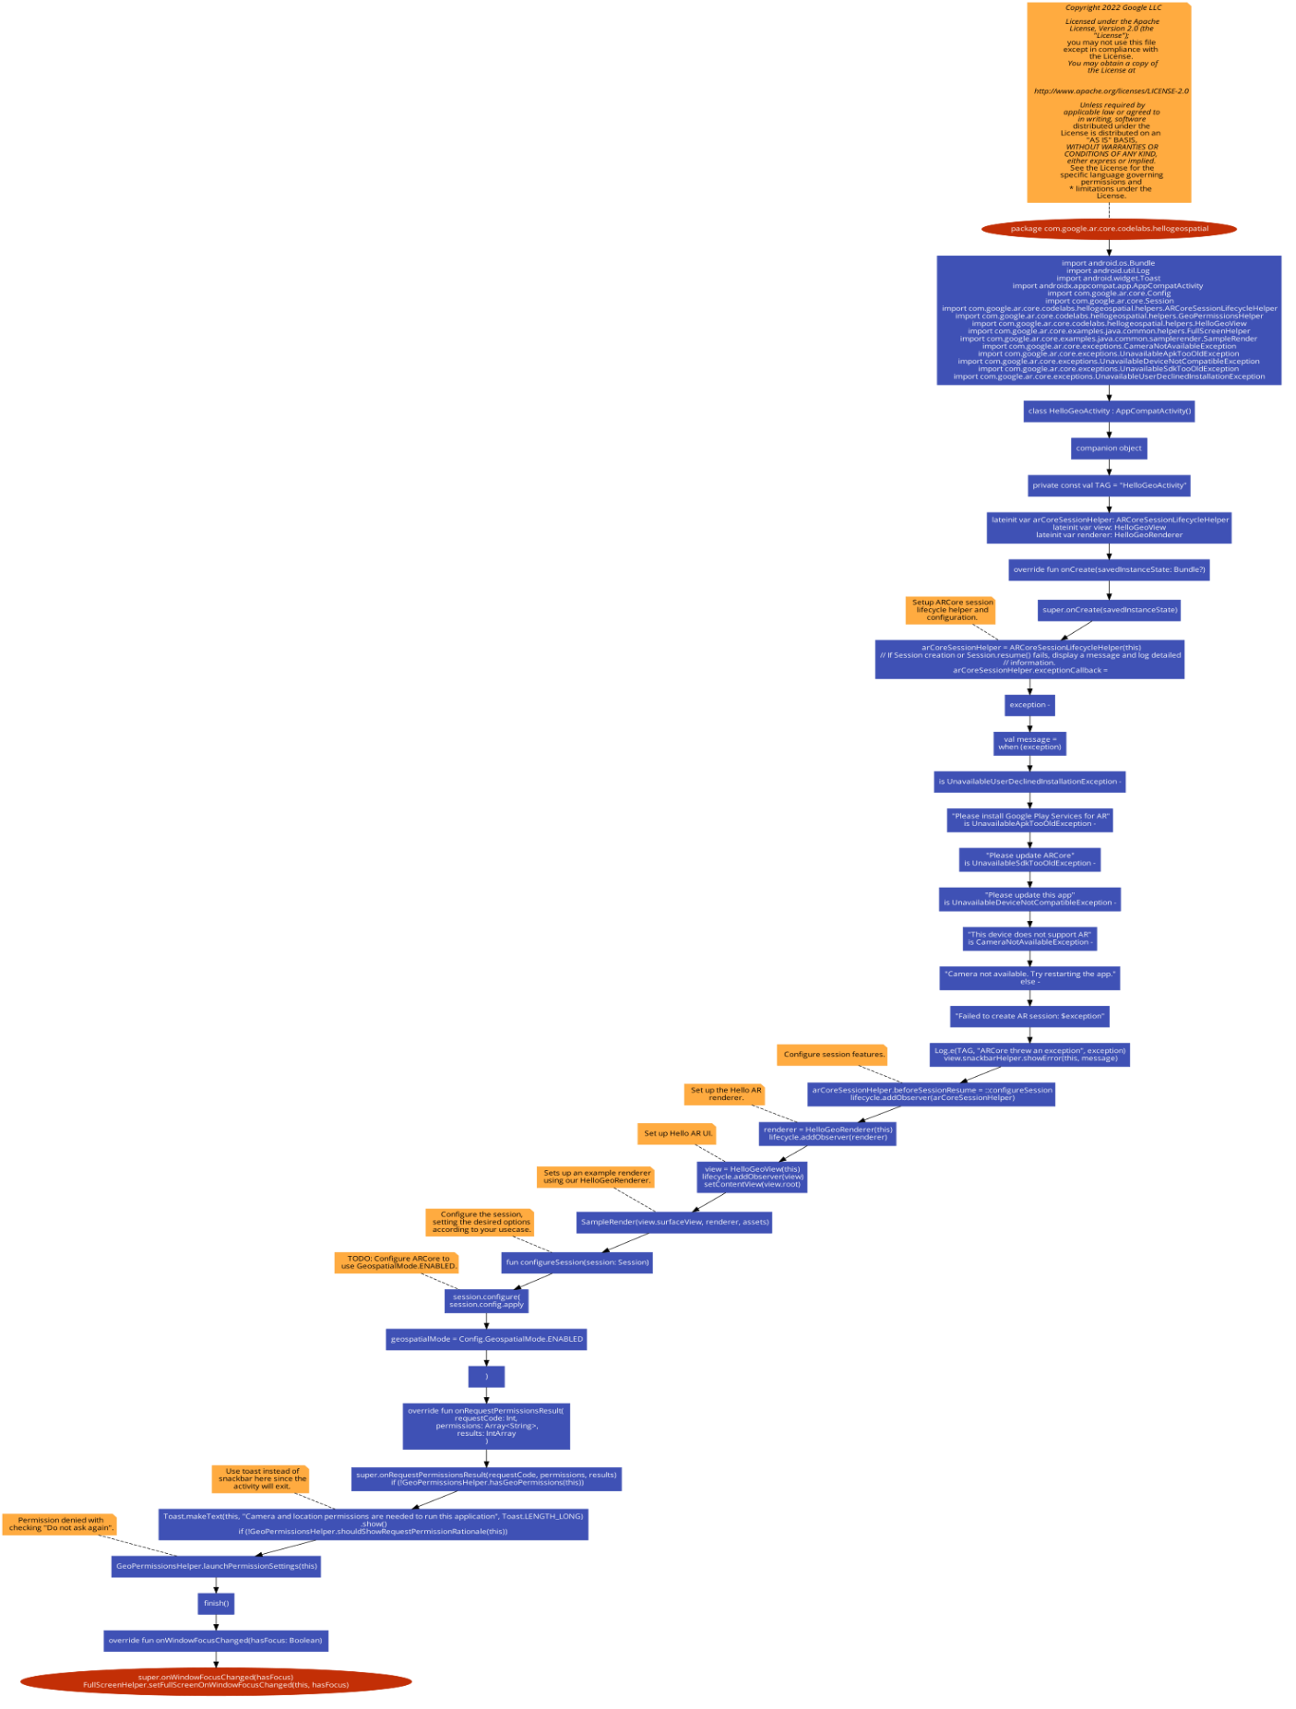

Fig 3.2 Flowchart

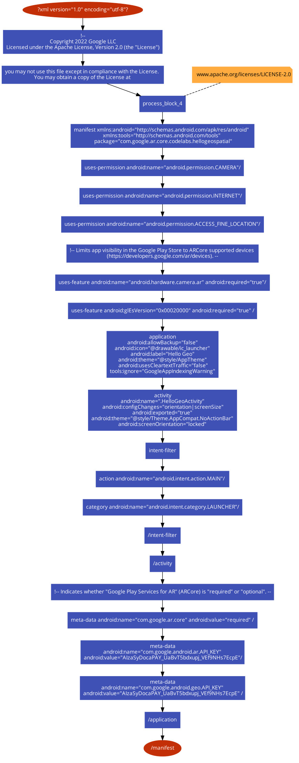

Fig 3.3 Flowchart

**Screenshot of coding part**

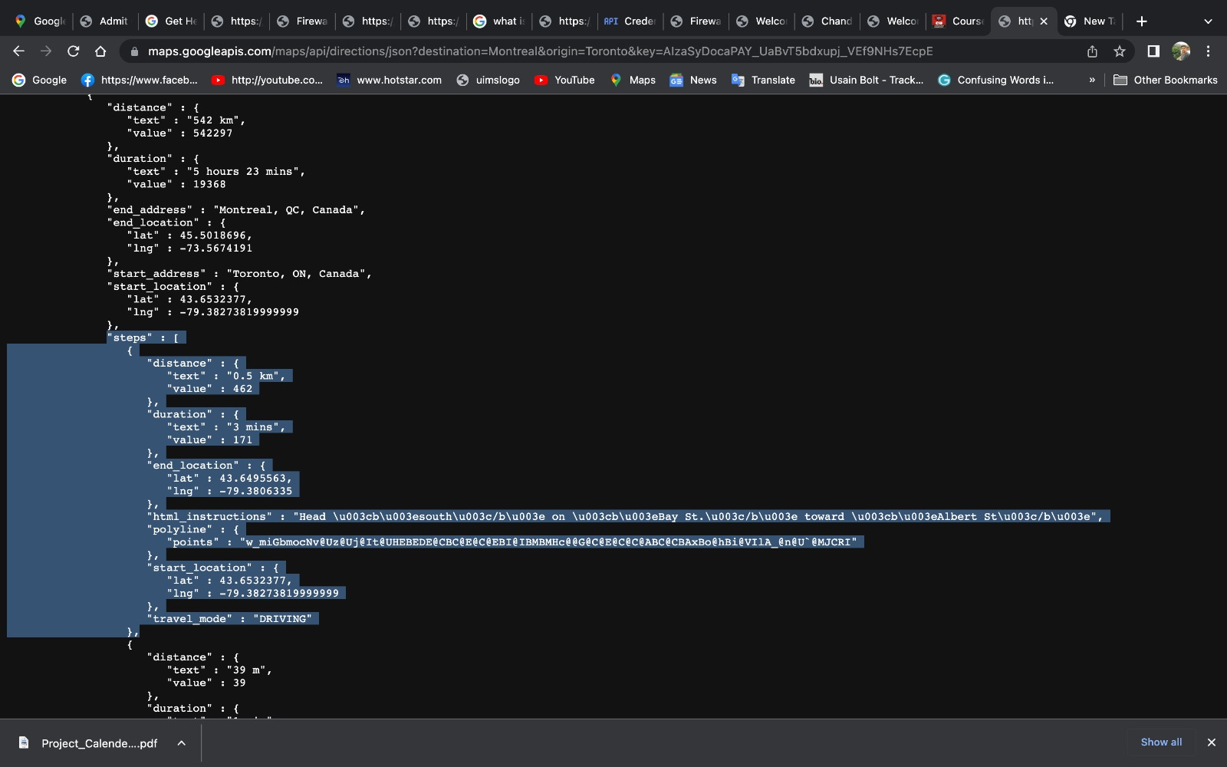

Fig 4.1

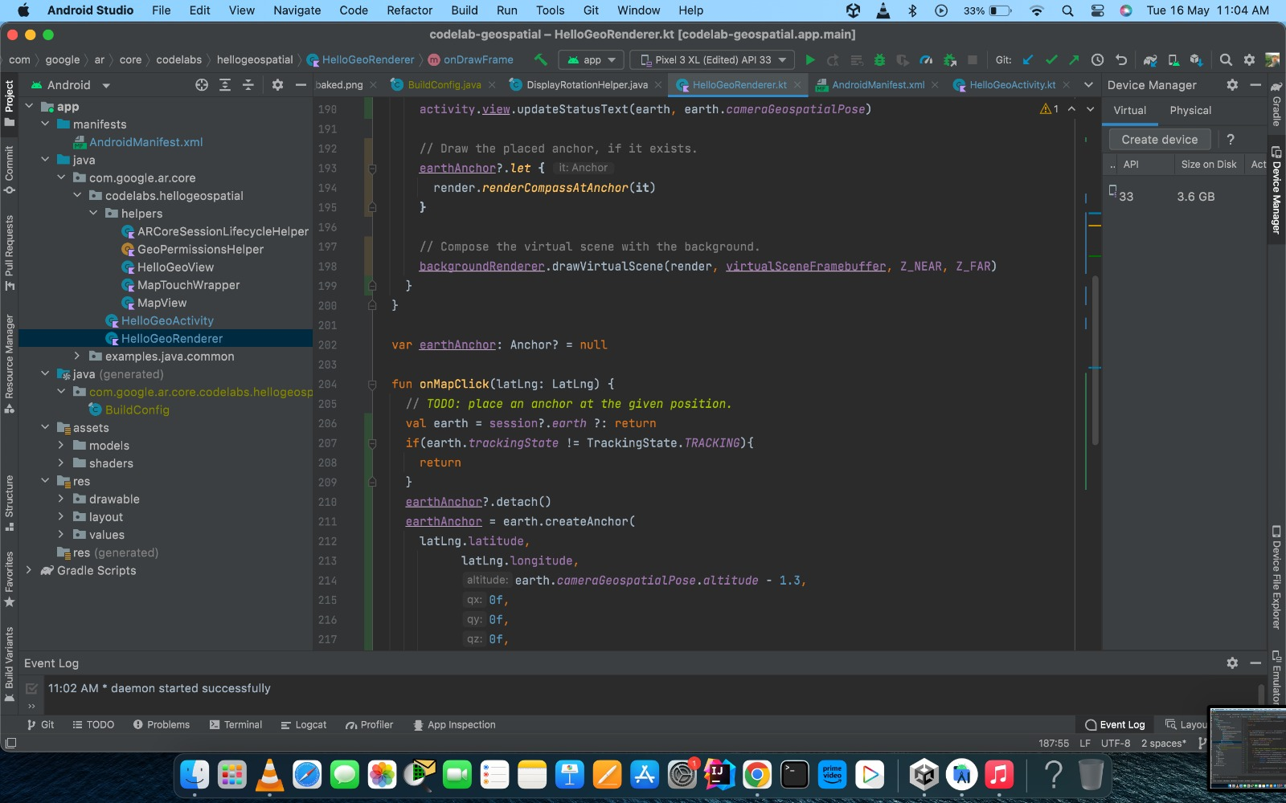

Fig 4.2

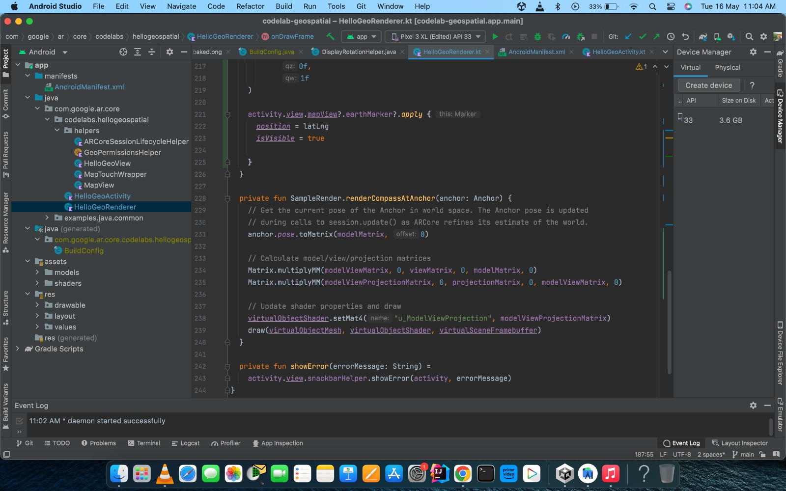

Fig 4.3

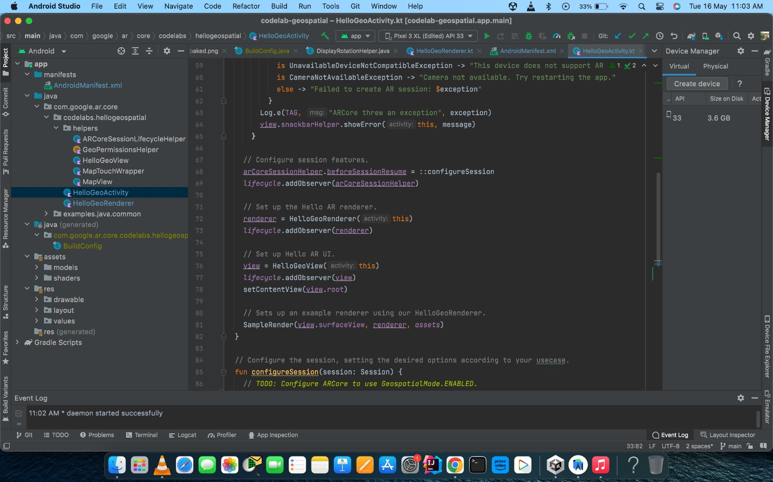

Fig 4.4

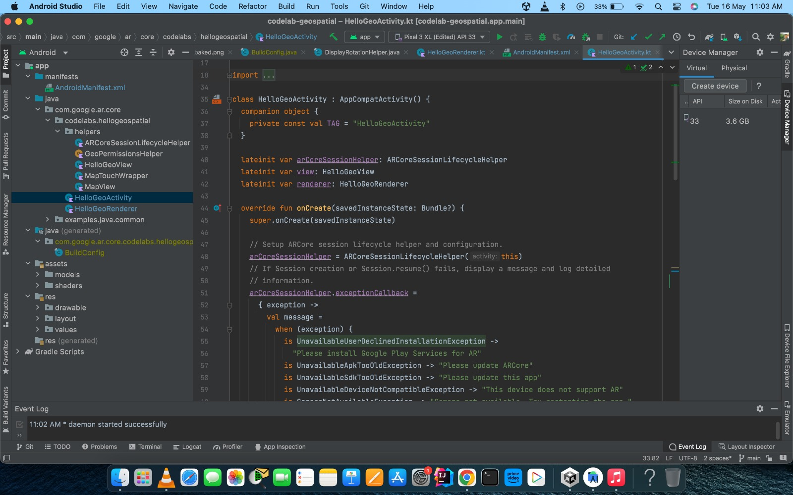

Fig 4.5

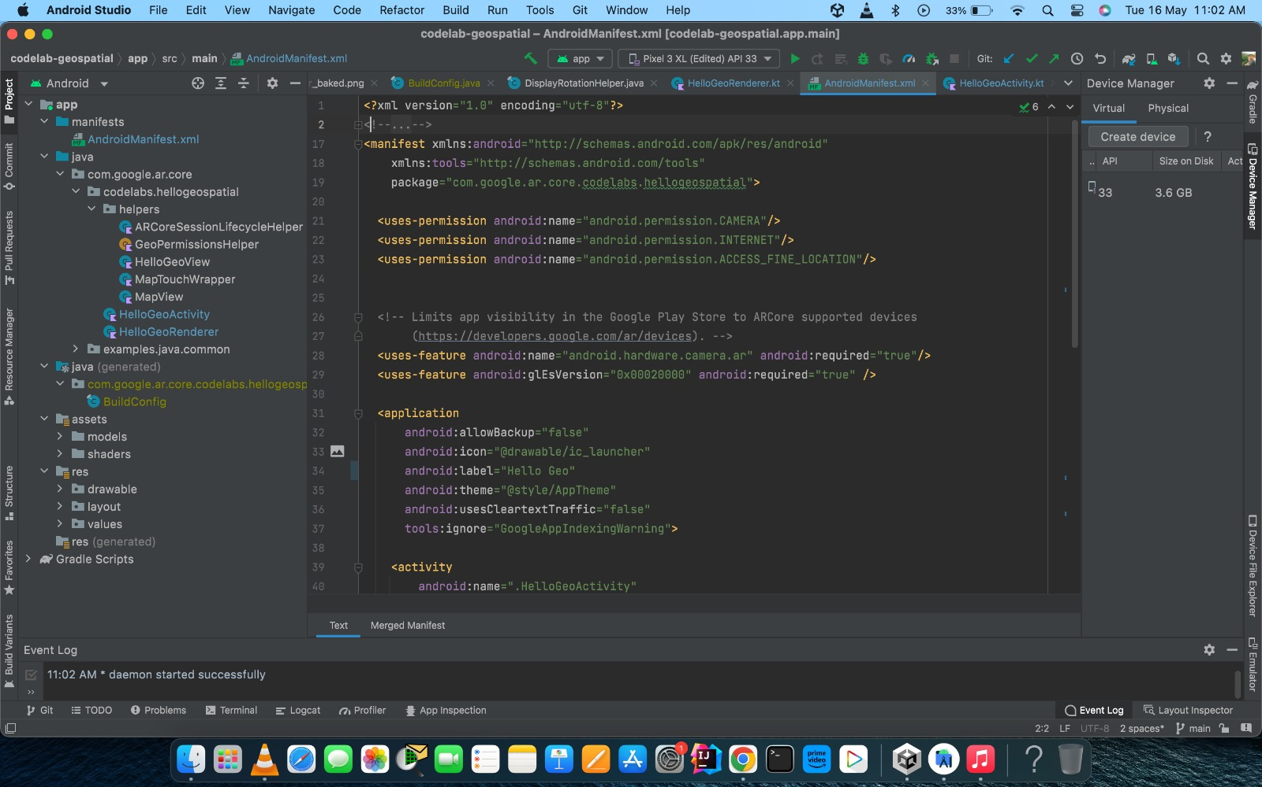

Fig 4.6

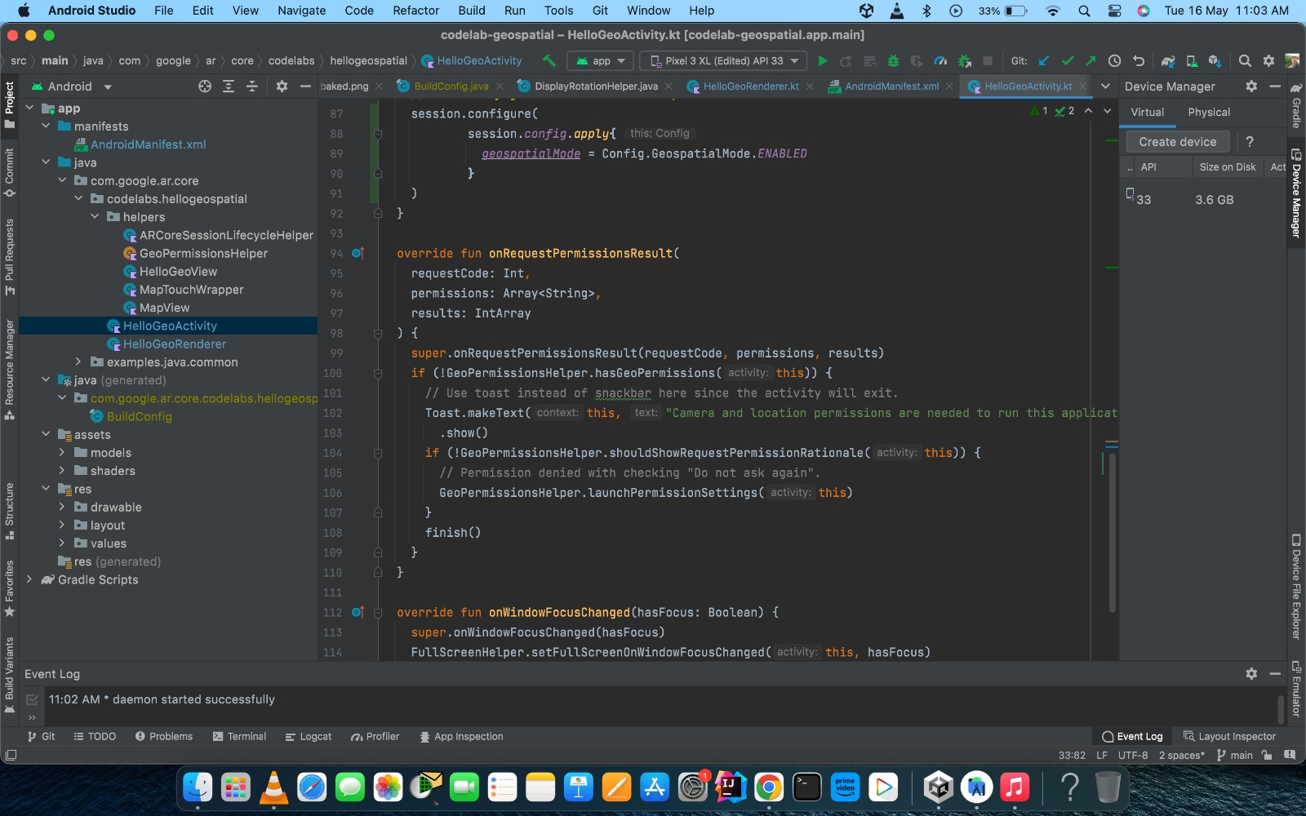

Fig 4.7

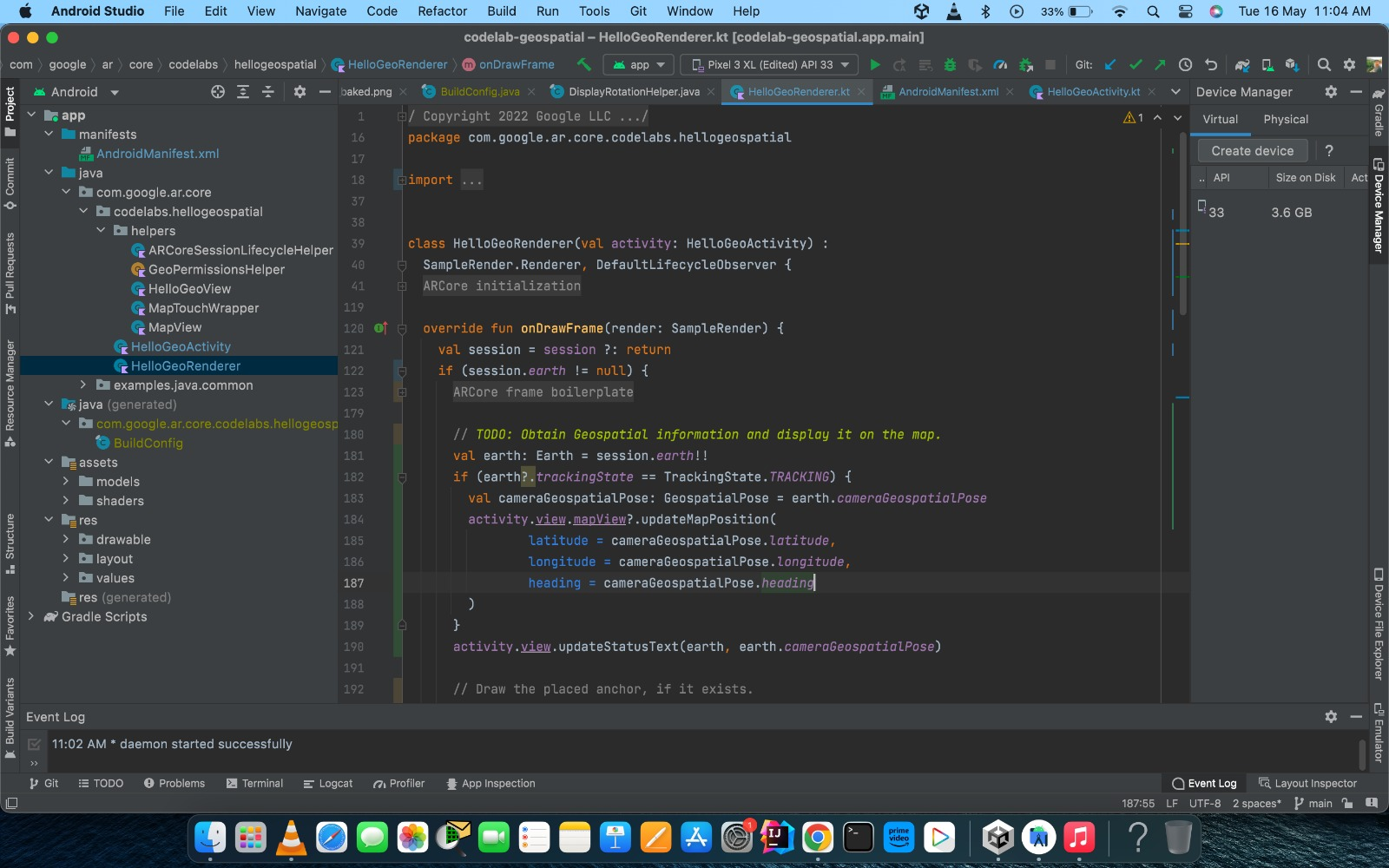

Fig 4.8

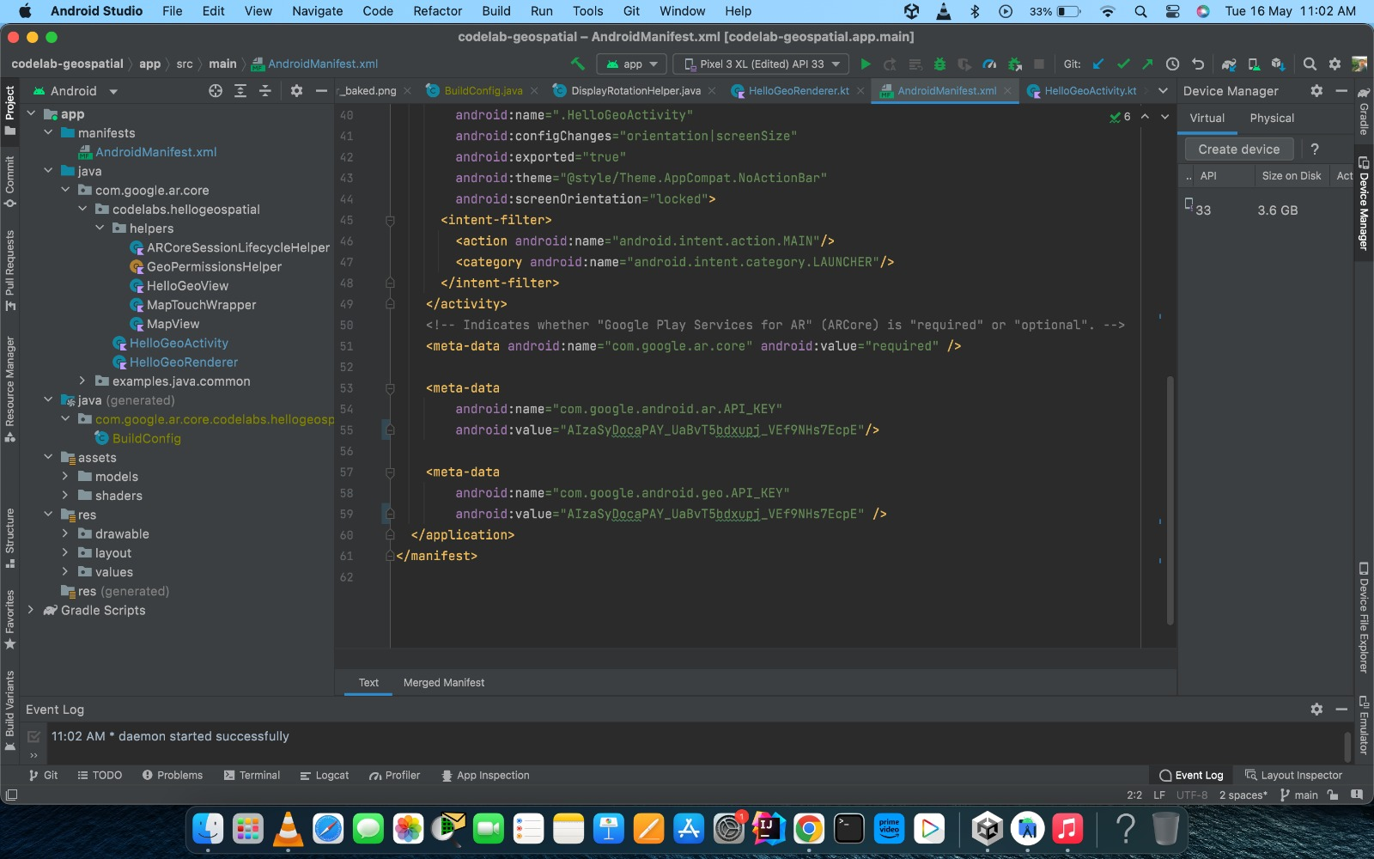

Fig 4.9

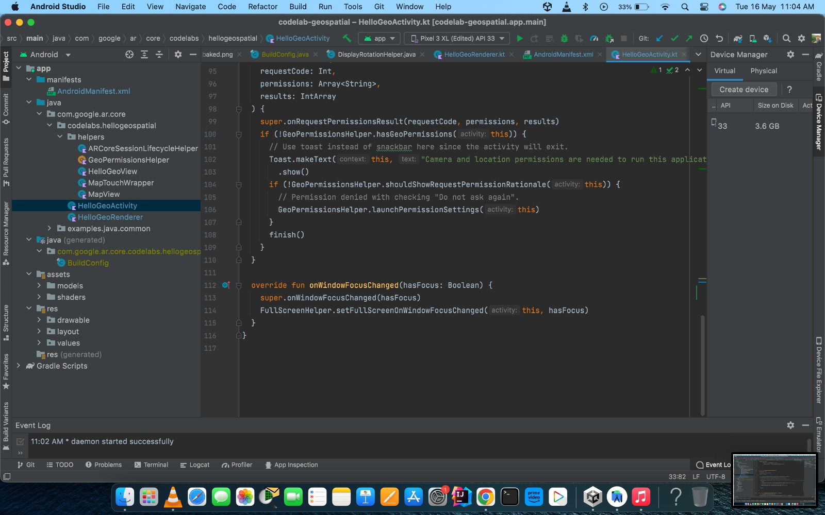

Fig 4.10

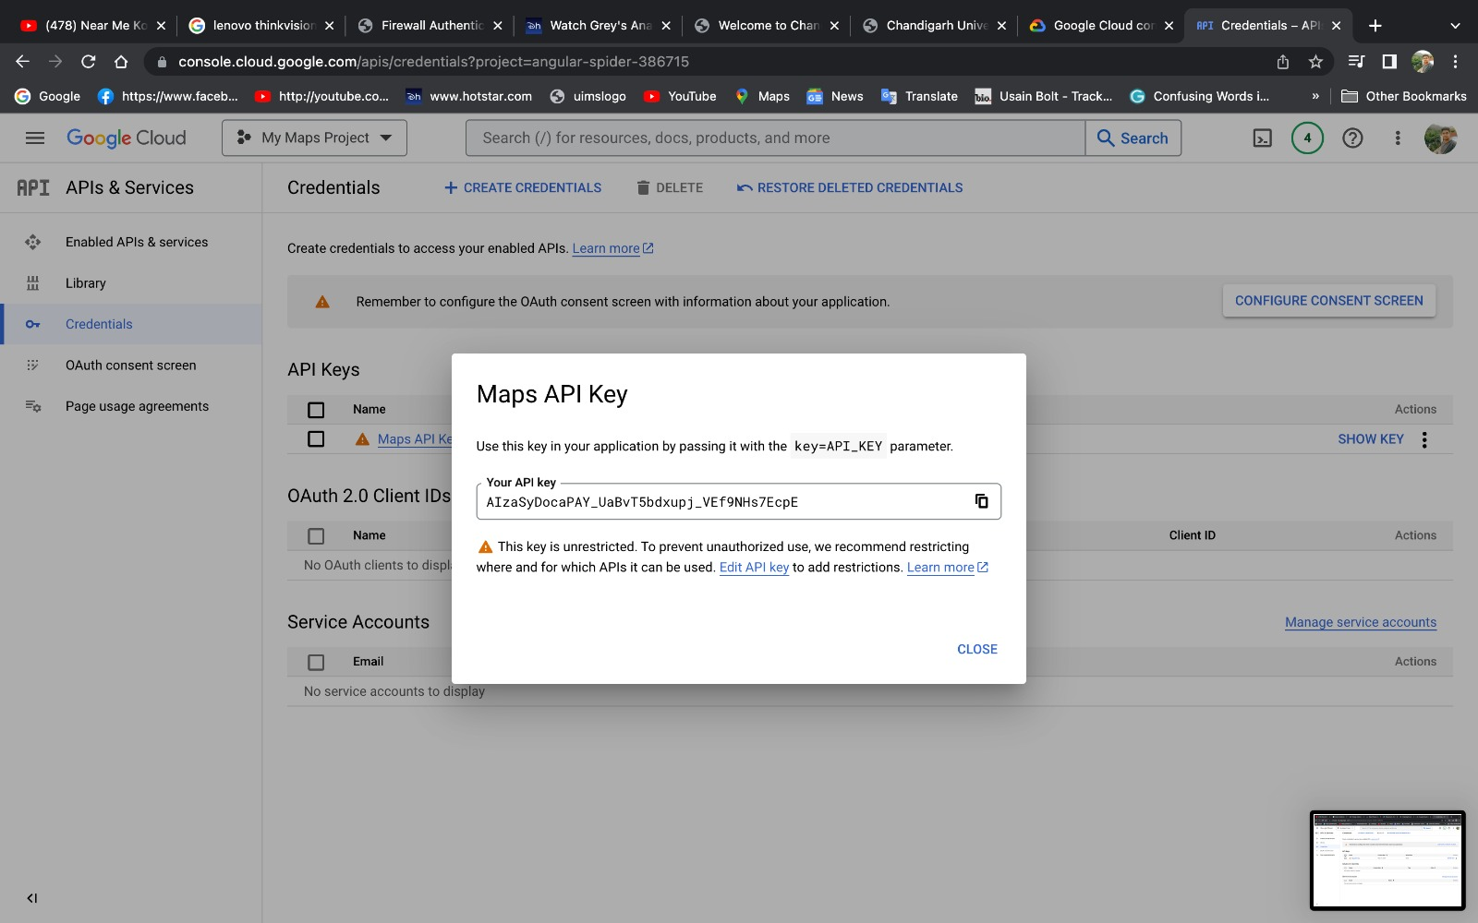

Fig 4.11

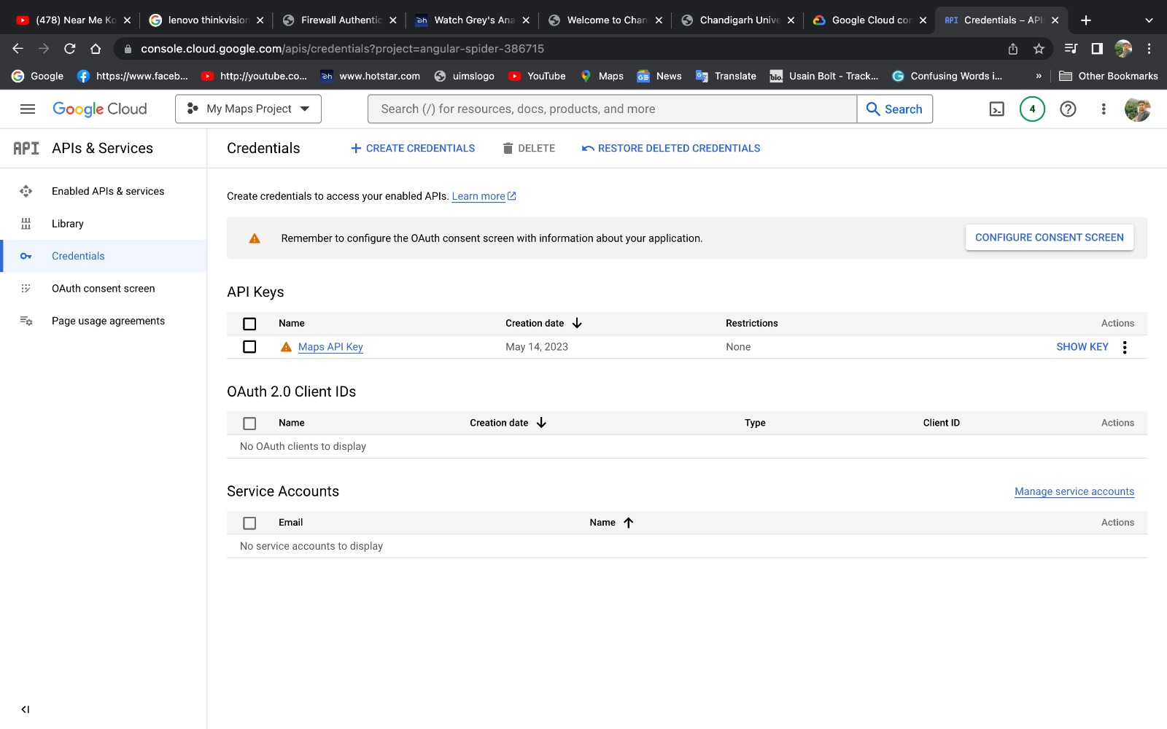

Fig 4.12

# Final project output

# 

Fig 4.13 Fig 4.14

# 

Fig 4.15 Fig 4.16

1. **Bibliography/References**

* Azuma, R. T. (1997). A survey of augmented reality. Presence: Teleoperators and Virtual Environments, 6(4), 355-385.
* Billinghurst, M., & Kato, H. (2002). Collaborative augmented reality. Communications of the ACM, 45(7), 64-70.
* Jiang, C., & Billinghurst, M. (2018). A survey of navigation aids for augmented reality. IEEE Transactions on Visualization and Computer Graphics, 24(2), 1030-1051.
* Grubert, J., Langlotz, T., & Zollmann, S. (2017). Augmented reality head-up displays: Presenting visual cues in the driver's line of sight. IEEE Computer Graphics and Applications, 37(5), 40-51.
* Wagner, D., & Schmalstieg, D. (2007). ARToolKitPlus for pose tracking on mobile devices. In Proceedings of the 6th IEEE and ACM International Symposium on Mixed and Augmented Reality (ISMAR) (pp. 87-90).
* Fan, C., Li, H., Zhang, Y., & Ruan, B. (2020). A review of mobile augmented reality applications and future challenges. Multimedia Tools and Applications, 79(25), 17669-17695.
* Yang, Z., Zhang, J., Yu, K., Guan, X., Huang, Y., Zhang, X., ... & Yu, T. (2019). Design and implementation of a marker less outdoor augmented reality navigation system. IEEE Access, 7, 119220-119233.
* Wang, X., Peng, S., Huang, Z., & Li, Y. (2021). An augmented reality indoor navigation system based on marker less tracking. Future Generation Computer Systems, 121, 502-514.
* Yeo, W. H., & Lee, H. J. (2020). A study on the development of augmented reality navigation system for smartphones. International Journal of Smart Home, 14(5), 175-186.
* Zeleznik, R., Forsberg, A., & Strauss, P. (1996). Two pointer input for 3D interaction. In Proceedings of the SIGCHI Conference on Human Factors in Computing Systems (pp. 191-192)